**LESSON 3 INTRODUCTION TO EXCEL LOGICAL FUNCTIONS**

**POINT 1 INTRODUCTION**

The logical functions in Excel are extremely useful, and often indispensable in everyday work. It is hard to imagine a serious spreadsheet e.g. without built-in IF function. The logical functions are primarily used to check whether the values entered in the worksheet’s cells meet the conditions. Only rarely are they used alone, most often they are nested in formulas, being arguments for other functions (often they return a table of numerical values ​​as a parameter for mathematical or statistical functions).

**Learning effects**

Once the material of this lesson has been mastered, the student should be able to easily solve the basic problems associated with the use of logical functions in Excel.

For example :

"Create a formula that will grant a discount on monthly tickets or not, according to the following principles:

People who are entitled to discounts need to meet two conditions simultaneously:

a) be retired

b) their monthly income per capita cannot exceed 600 zł "



**Point 2 Basics of logical functions**

TRUE()

This function has no arguments, it always returns the logical value TRUE. You can also enter this value directly into a cell or formula.

FALSE()

This function has no arguments, it always returns the logical value FALSE. You can also enter this value directly into a cell or formula.

Both of these functions seem to be absolutely unnecessary in Excel and have been introduced in order to comply with other spreadsheets.

IF()

This function checks the logical condition specified in the first argument of the function. If the condition is fulfilled (TRUE) then the value of the second argument is returned, and if not (FALSE) - the value of the third argument is returned.

The syntax of the IF function () is presented below:

• logical-test - to check the logical condition of a value or expression, the result of which can be calculated as a logical value (TRUE or FALSE). The logical condition often uses logical comparison operators such as =,>, <,> =, <=, <> to show the values of cells. For example, B2 = 9 is a logical expression; if the value entered into cell B2 is actually number 9, this expression will be evaluated to TRUE, in any other case, the expression will have the logical value FALSE

• value_if_true - the second argument of the function is the value returned when the first argument logical_test is met. If our logical test is the expression B2 = 9 and in the cell B2 there is in fact number 9, then the result of the function - the value of the second argument - may be a text message "in this cell there is number 9". This is an optional argument that can be omitted by placing two semicolons after the first argument. Omitting it indicates that it is a default argument, whose resulting value is TRUE

• value_if_false - the third argument of the function is the value returned when the first argument logical_test returns the value FALSE. If our logical test is still the expression B2 = 9, and in cell B2 there is a different value (number, text, error, logical value) or the cell is empty, the result of the function (the value of the third argument) can be a text message "the value of this cell is different from number 9". Leaving the argument empty will result in returning the value FALSE. Two optional arguments CANNOT be omitted at the same time, at least one of them should be determined

The use of IF function is presented below

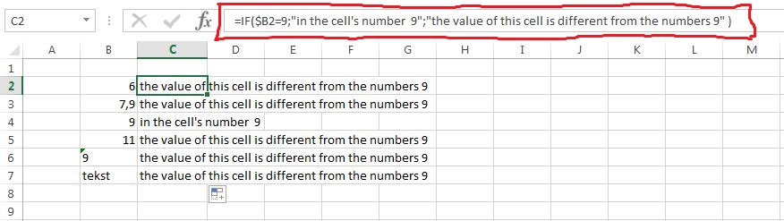

=IF(B2 = $ 9; "in this cell is number 9"; "the value of this cell is different from the number 9")

The result of the function is presented depending on the value of the cell on the left side of the formula. Only in one case, the logical expression is true. Excel does not apply automatic conversion here and properly distinguishes numeric values from the text, that’s why number 9 that is preceded by an apostrophe is treated as text (logical condition returns FALSE, while the formula - the text that is included in the third argument of the function value_if_false).

**Point 3 Examples of logical function IF ()**

The first example shows the logical condition with statistical function. Apart from the comparison operator that has been mentioned above we use here statistical function AVERAGE ().

The task is to reward students who have obtained the average grade of at least 4.50 in the given subjects - they are entitled to a scholarship for their academic performance.

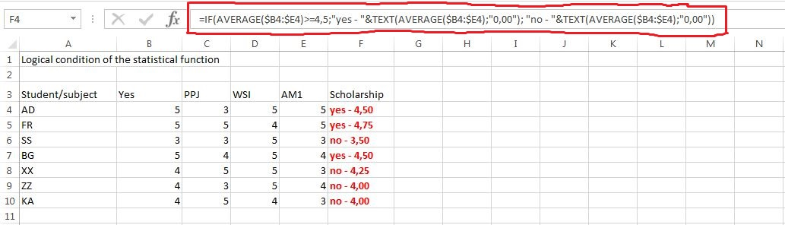

The formula in cell F4 checks the average of four subjects and it looks like this:

=IF(AVERAGE ($B4:$E4)>= 4.5; "yes - "&TEXT(AVERAGE($B4:$E4);"0.00");  
"no - "&TEXT(AVERAGE ($ B4: $ E4), "0.00"))

The most important in this case is the logical condition, that is checking whether the average of the four subjects is higher than or equals 4.50. If this happens, the formula returns the text

"yes –“ and shows the average grade for the student, otherwise it returns the text "no -" together with the average grade. Another way is to create two separate columns: average grade, and information about the scholarship (in this case, it is possible e.g. to sort by average).

The second example shows nesting of the function IF (). Some logical problems can be solved only after multiple nesting of this function e.g. when the need to allocate the grade according to the value range in which the score is.

Below there is a table in which students were assigned grades according to the number of points obtained in the exam.

The formula for cell C4 is:

= IF ($ C4> 18; "very good"; IF ($ C4> 14; "good"; IF ($ C4> 10; "satisfactory", "unsatisfactory")))

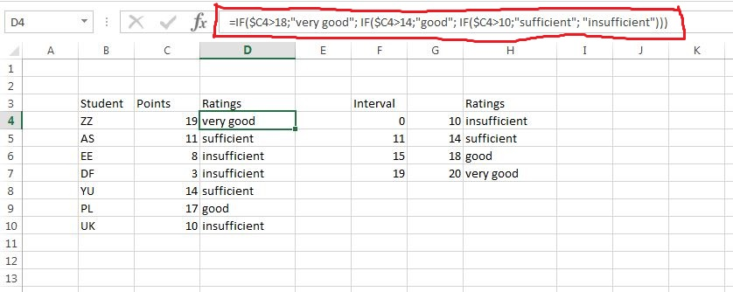

It is worth to remember a few important things:

• The IF () can be nested up to 7 times in a formula in Excel 2003. For Excel 2007 you can nest it up to 64 times, but the formula will not work correctly in the earlier versions of Excel, so it is advisable to use up to 7 nestings in a single formula. In case of our formula the function IF ()has been nested three times.

• The second instruction of IF function () is simultaneously an argument value_if_false for the first instruction of the function (view 4). Similarly, the third instruction of IF function () is an argument value_if_false for the second instruction and so on.

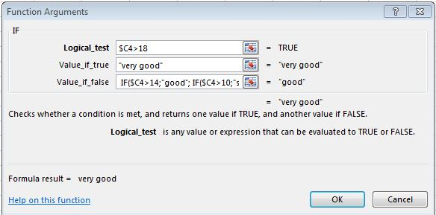

• The formula checks the first logical condition and stops when it returns TRUE (as a result it returns the value of the second argument). If the returned value is FALSE - the formula moves to the second condition etc. In our example (score = 11), the first condition $ C5> 18 is false, the second $ C5> 14 also returns FALSE. Only the third $ C5> 10 is met - the result of the formula is thus the word "sufficient".

• For any number of points lower than 11 each of the three conditions returns FALSE. In such situation (in another case)the formula returns the word "unsatisfactory".

**Point 3 The AND () function - Expansion function IF ()**

**AND()**

The AND () works in conjunction with IF (), extending its operation. IF () in basic form operates only one logical condition, while the AND () allows you to enter up to 30 logical conditions. To perform function as a result of TRUE, it is necessary that each of the conditions, function arguments, he was satisfied. If at least one of the accepted conditions is FALSE, the function returns a result of FALSE.

AND () it is therefore, in other words, the product of (a conjunction) conditions. Be very careful to keep all function arguments logical values using other types of values, as very simply, you can generate an error. Using arguments and empty text is permitted only in particularly justified cases - only if the second argument is a reference to an empty cell or one that contains text, the formula will work - the data entered in the parameters manually generate this error #VALUE !.

The following table is presented on the basis of which in a very useful function can be used, AND (). The task concerns the selection of candidates for the position of Analyst in our company. In total, it reported seven people who were tested in various fields. The assumption is that we are interested in people who are very familiar with English, Excel, and have obtained at least 15 points in our test checking the knowledge of controlling. If the candidate meets all these conditions, it is admitted to the second stage of recruitment; otherwise eliminated.

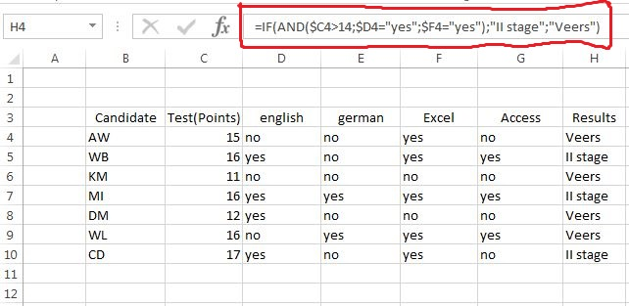

The formula contained in the H4 as follows:

= IF(AND($C4>14; $D4="yes";$F4="yes");"Stage II", "Not applicable")

• For the first person formula returns the text '' Void '' because it was not satisfied with the conditions of the other very good knowledge of English. Although the other two conditions have been satisfied - AND function () returns a result of FALSE, and the function IF () converts a specific text message.

**Point 4 The OR () function - Expansion function IF ()**

OR()

The OR () - like function AND () - interacts with function IF (), allowing for a more extensive tests. If you want the function to pay as a result of TRUE, it is required that at least one of the conditions, function arguments, he was satisfied. If all of the accepted conditions are FALSE, the function returns a result of FALSE. OR () it is therefore, in other words, the sum of (alternative) conditions. Using arguments and empty text it is handled by a function similarly to the function AND ().

The following tables present the same as for the AND () but with different results. This time we carry out recruitment for the position of Specialist. Database, because the eligibility criteria for the next stage are different. The candidate this time must meet two conditions: be fluent in Access, and at least one of the two languages.

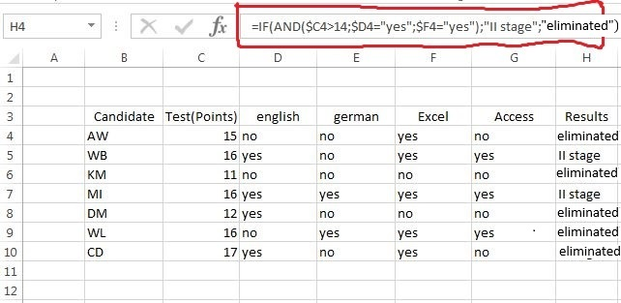

The formula contained in the H4 as follows:

= IF(AND($G4="yes";OR($D4="yes";$E4="yes")); "Stage II";"eliminated")

• Here we have a combination of conjunctions and alternative conditions. Conjunction is that the candidate must meet two conditions, an alternative that requires a good knowledge of any foreign language.

CHECKING THE KNOWLEDGE:

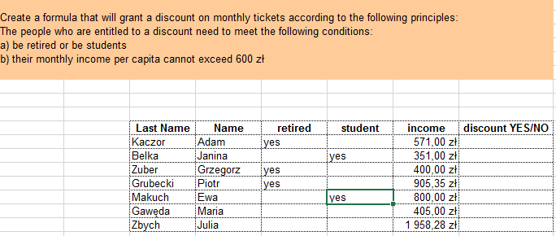

a) =IF(AND(G12="yes";E12<=600);"discount";"without discounts")

b) =IF(AND(G12<600;OR(E12="yes";F12="yes")); "discount", "no discount")

c) = IF (AND(G12<=600;OR(E12="yes"; F12="yes")),"discount","no discount")   
- AND at the beginning because we have to choose options A and B and then oR (students or retirement) and G12<=600 (not to exceed 600 zł)

**5. Summary**

In addition to the IF function () all logical functions return as a result of the logical type TRUE / FALSE. The IF () can be used in many different ways: by means of nesting you can check a number of different conditions; treating each cell in the range as a parameter to a function of mathematical, statistical or information, you can make calculations (eg. to count or sum up) only in those cells that meet certain criteria. Functions AND () and OR () operate on individual cells and allow you to develop logical tests, which are very often used in the making of advanced formulas. We encourage you to own adventure with logic functions.

**Test**

**In the attached file**

**SXXXXX-WSI-INTERNET-TEST-EXCEL-LOGICAL-FUNCTIONS.xlsx**

**Scoring max 10**

**0.5 + 1 + 2 + 2 + (9 * 0.5)**